
CELA Strategic Plan 2026–2031

Expanding Equitable Access to Reading
June 2026

Table of contents
Message from CELA 3
Strategic direction 5
Guiding principle 5
Purpose 5
Mandate 5
Strategic pillars & objectives 6
Effective service delivery & reading experience 7
Diverse, responsive collection 7
Reach & impact through partnerships 8
Sustainable, future-ready foundation 8

Message from CELA
June 2026
On behalf of the Centre for Equitable Library Access (CELA) Board of Directors and staff, we are pleased to share CELA’s strategic plan for the next five years. We are grateful to the users, public libraries, educators, partners, funders, and many others who contributed their time, perspectives, and experience to the planning process. Your input has helped shape a plan that reflects both the value of CELA’s work today and the opportunities ahead.
CELA is a national, bilingual, not-for-profit organization that provides access to reading materials for people with print disabilities – individuals who cannot read traditional print due to visual, physical, or learning disabilities.
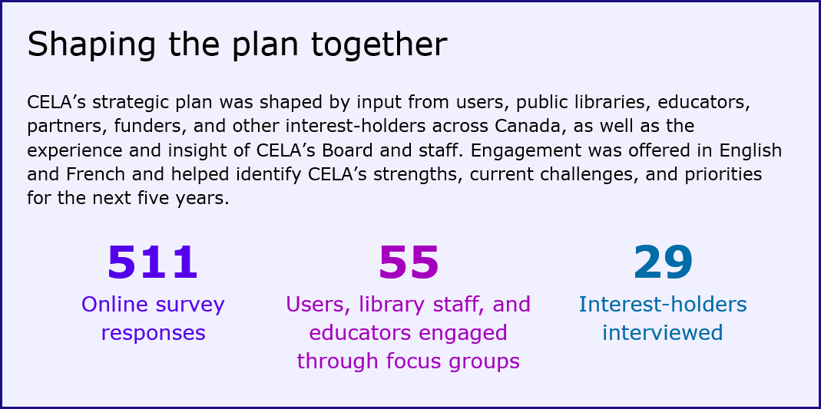
CELA plays a critical role in enabling people with print disabilities to participate in reading. Through a shared service model – working with public libraries and other partners across Canada – CELA offers a broad collection of materials in accessible formats, along with the tools, supports, and infrastructure needed to use them.
This strategic plan sets direction for the next five years. It clarifies CELA’s role and priorities, reinforces the position of the accessible reading ecosystem as essential, and supports more consistent and effective delivery of accessible reading services through public libraries and partners across the country. The plan is informed by engagement with users, public libraries, provincial and territorial library services, educators, and a range of external partners, and reflects a shared interest in building on CELA’s strengths while responding to ongoing challenges in how services are delivered and experienced.
The plan presents a refreshed purpose statement and mandate, along with a set of strategic pillars and objectives that define priorities for the organization over the next five years. It is designed to be practical and adaptable, recognizing that the environment in which CELA operates will continue to evolve. Progress will require ongoing learning, iteration, and collaboration, supported by strong use of data and user insight, and a continued focus on the people CELA exists to serve.
We look forward to working with users, libraries, partners, and the broader accessible reading community to advance this plan and strengthen equitable access to reading across Canada.
On behalf of CELA,
Laurie Davidson, Executive Director
Carolyn Minor, Board Chair

Land acknowledgement
As an organization working across what is now known as Canada, we gratefully acknowledge First Nations, Inuit, and Métis communities for their guardianship of this land, while recognizing the historical oppression of their ancestral cultures and populations. We respect and affirm the inherent and Treaty Rights of all Indigenous Peoples across the country and remain dedicated to supporting their self-determination and sovereignty.
It is our hope that this plan will strengthen the foundation for enduring and purposeful relationships between Indigenous peoples and CELA, honouring and respectfully sharing Indigenous stories and voices.
Strategic direction
CELA’s guiding principle, purpose, and mandate set the foundation for our strategic direction over the next five years.

Guiding principle
What guides our work
CELA’s work is grounded in the expertise and lived experience of people with print disabilities. Their perspectives shape the organization’s priorities, services, collections, partnerships, and ongoing decision-making.

Purpose
Why we exist
CELA is committed to the fundamental right to read. We exist to enable equitable access to reading for people with print disabilities across Canada. As an essential national service, we work with public libraries, educators, and other partners to ensure people with print disabilities can fully participate in reading, opening up opportunities for learning, work, social connection, and everyday enjoyment.

Mandate
What we are responsible for
- Providing accessible reading materials for people with print disabilities in Canada.
- Supporting public libraries and other service delivery partners with tools, guidance, and resources to help them connect people to accessible reading materials.
- Strengthening the accessible reading ecosystem through cross-sector partnerships that improve the content, technology, and infrastructure for accessible reading in Canada.
- Championing equitable access to reading for people with print disabilities.

Strategic pillars & objectives
CELA’s work is national in scope, facilitated through public libraries, and supported by partners across the accessible reading ecosystem. The following strategic pillars are equally important and mutually reinforcing. Together, the pillars and objectives position CELA to strengthen its services while contributing to a more coordinated, sustainable, and equitable approach to accessible reading across Canada – one that helps people with print disabilities find, access, and use the materials they need. This structure provides a clear framework for advancing CELA’s work while allowing flexibility to respond to evolving needs, technologies, and opportunities.
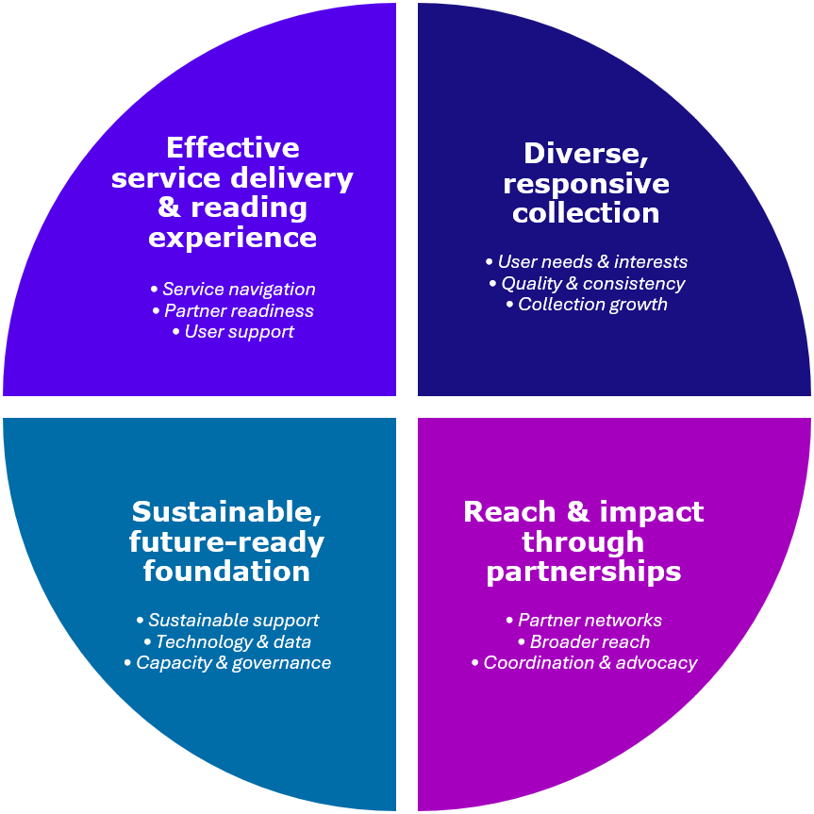

Effective service delivery & reading experience
Improving how people discover, access, and use CELA services and accessible reading materials is central to this area of work. This pillar includes strengthening the reading experience for users while ensuring that public libraries and other service delivery partners have the training, guidance, and support needed to assist users. This work is continually informed by user feedback and the lived experience of people with print disabilities, helping ensure service improvements reflect real needs and experiences.
Objectives:

Users can easily and reliably navigate CELA services to discover, access, and engage with accessible reading materials.

Public libraries and other partners have the training, guidance, and support needed to deliver CELA services effectively.

Users have the training, guidance, and support needed to use CELA services and related accessible reading technologies.

Diverse, responsive collection
A diverse, responsive collection is one that reflects what people want to read, in the formats they need. This pillar focuses on strengthening the breadth, responsiveness, quality, consistency, discoverability, and usability of CELA’s collection over time. It also involves continually improving and expanding available materials through production, purchasing, partnerships with other accessible reading services, and collaboration with industry to support born-accessible content.
Objectives:

CELA’s collection is diverse, responsive, and reflective of user needs, interests, and format preferences.

The quality, consistency, discoverability, and usability of accessible formats continue to improve over time.

Users benefit from a growing collection developed through production, purchasing, partnerships, and collaboration.

Reach & impact through partnerships
Partnerships are essential to connecting more people with accessible reading. This strategic area focuses on strengthening delivery through public libraries, improving pathways into services, expanding reach through cross-sector relationships, addressing gaps in access, and supporting stronger coordination across the accessible reading ecosystem.
Objectives:

More people are connected to CELA services through strong partnerships and clear referral pathways across key sectors.

Gaps in access to CELA services in non-participating jurisdictions are better understood and addressed to support broader reach.

CELA plays an active, collaborative role in coordination and advocacy within the accessible reading ecosystem, print disability rights, and the broader library sector.

Sustainable, future-ready foundation
A strong and forward-looking foundation is necessary for CELA to deliver on its mandate over time. This work includes building recognition of the value of accessible reading, advancing the case for sustainable investment in an equitable and accessible reading ecosystem, and ensuring CELA has the capacity, governance, and infrastructure required to respond to evolving needs.
Objectives:

The role and value of an equitable and accessible reading ecosystem are widely understood, recognized, and sustainably supported.

CELA’s technology and data systems support reliable service, informed decisions, and readiness for future needs.

CELA has the organizational capacity, governance, and resilience needed to deliver its mandate as needs and demands evolve.

