Getting started guide: Victor Stratus4 M

Contents

Overview 2

About the Stratus4 M 2

Where to get Stratus4 M 2

How to get books or magazines 2

Layout of Stratus4 M 3

Stratus4 M diagram 3

Stratus4 M layout description 3

How to listen to a book or magazine with Stratus4 M 4

Choosing a book 4

Playing a book 5

How to remove books from your Stratus4 M 5

Where to get help 6

Useful tips 6

## Overview

This guide provides basic information to get you started with reading CELA books and magazines on the Stratus4 M.

## About the Stratus4 M

The Victor Stratus4 M is a simple to use digital talking books player. Other than reading books on CD, internet compatible versions of the Stratus4 M can also connect to your CELA account and download books over a wireless internet connection or by using an SD card or USB key.

## Where to get Stratus4 M

The Stratus4 M may be obtained directly from the manufacturer (HumanWare), or from CNIB SmartLife or other distributors. Some provinces may offer subsidy programs to support purchasing a player for users with print disabilities.

[Stratus4 M at HumanWare](https://store.humanware.com/hca/victor-reader-stratus4-m-daisy-mp3-player.html)

[Stratus4 M at CNIB SmartLife](https://cnibsmartlife.ca/products/victor-reader-stratus-4m-unconfigured)

## How to get books or magazines

There are a few options to receive digital audiobooks from CELA on your Stratus4 M without using CDs. These depend on the model of your Stratus. If your Stratus4 M is able to connect to a wireless network, the books you were previously receiving on CD can be placed on your personal Direct to player bookshelf. The Stratus connects to it and allows you to select and start reading any of the titles currently on your bookshelf. For more information to set up this service see [Setting up Direct to Player](https://celalibrary.ca/services/delivery-options/direct-to-player#setup).

To find out if your player is compatible with CELA’s Direct to player bookshelf service, press the Info key (in the middle of the arrow navigation keys) until you hear the model or version information. Our [Contact Centre](https://celalibrary.ca/contact-us) can help you determine if your player is compatible and set you up for Direct to player service.

If wireless internet access is not an option for you, the Stratus4 M may have the ability to read books from a SD card or USB drive. In this case, you will need to log in to your CELA account on a computer and download the books to the SD card or USB key. They can then be connected to your player, and you can start reading your books. For more information on loading books this way, see the tutorial: [How to transfer a DAISY .zip book to your Victor Stratus](https://celalibrary.ca/help/tutorials/how-to-transfer-daisy-book-zip-to-victor-reader-stratus).

## Layout of Stratus4 M

### Stratus4 M diagram

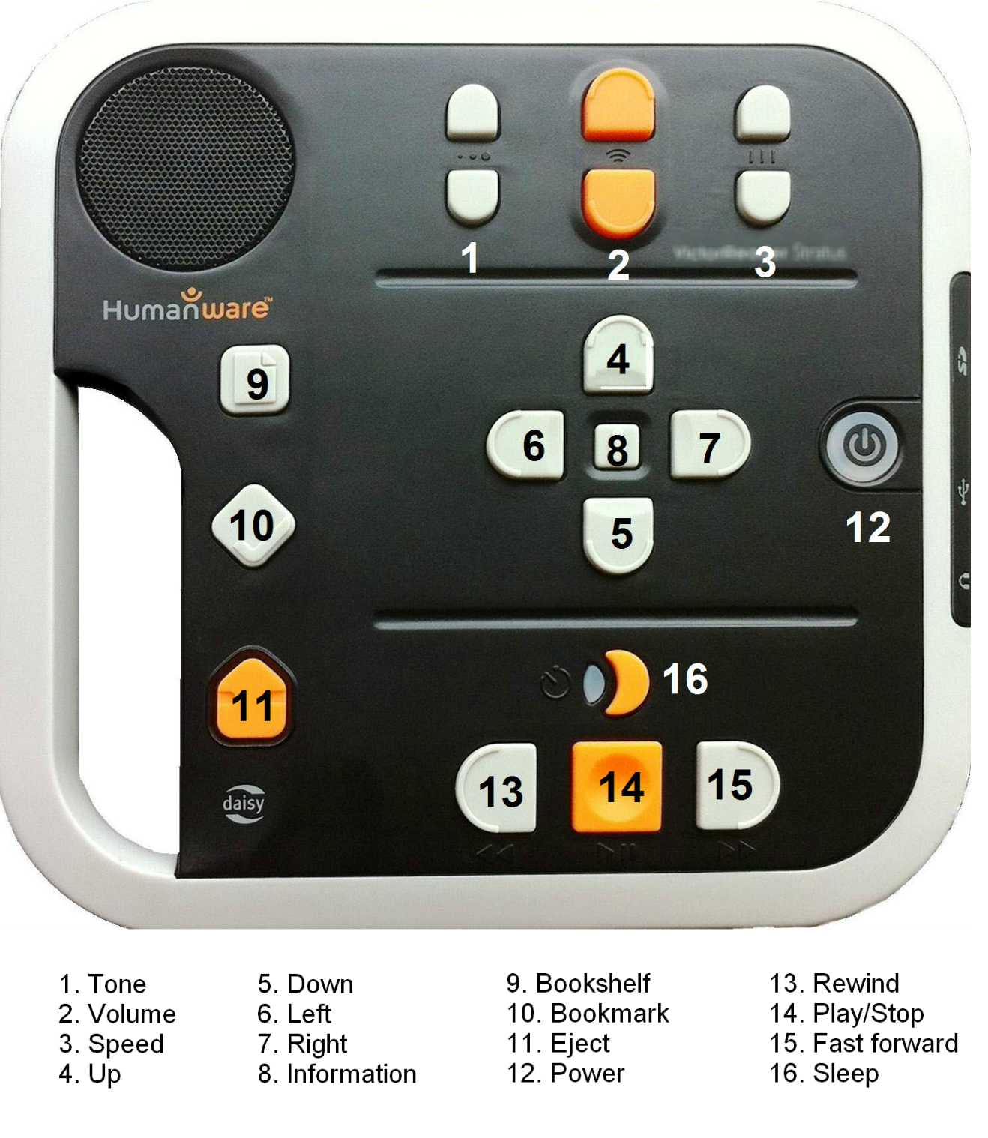

### Stratus4 M layout description

Your Stratus4 M may have a protective cover meant to avoid accidentally using some of the more advanced functions. This cover will need to be removed to access books from CELA. For instructions on how to remove it, see [Stratus4 M user guide](https://www.humanware.com/wp-content/uploads/2024/11/Stratus-4-M-UG-ca-en.doc) (Word document).

#### Layout (without protective cover)

The built-in speaker is located on the upper left corner of the face.

On the top centre, there are three pairs of up and down keys. From left to right, these are the **Tone, Volume** and **Speed** controls.

Beneath the Tone, Volume and Speed controls, in the centre of the face of the player, you will find the four arrow shaped navigation keys **UP, DOWN, LEFT** and **RIGHT** allowing you to easily move through the structure of a book. In the middle of these navigation keys is the **Information** key, giving info about current book, battery status, player model and more.

To the right of the four Navigation keys is the **Power** key. It is slightly recessed to prevent you from accidentally pressing it.

To the left of the four Navigation keys, about midway down the player, are three more keys.

* Bookshelf
* Bookmarks
* Eject (for removing CDs or deleting books from the player).

Beneath the four Navigation keys is a group of four keys. Three of them are lined up along the lower edge of the player. These are, from left to right, the **Rewind, Play/Stop** and **Fast Forward** keys. Finally, above the Play/Stopkey is the **Sleep** key. It is crescent shaped and has an orange LED.

## How to listen to a book or magazine with Stratus4 M

This guide assumes that you have already set up Direct to player service or connected an external storage device such as a USB drive or SD card loaded with books from CELA. For more information, see tutorials for [Setting up Direct to Player](https://celalibrary.ca/services/delivery-options/direct-to-player#setup) and [How to transfer a DAISY .zip .book to your Victor Stratus](https://celalibrary.ca/help/tutorials/how-to-transfer-daisy-book-zip-to-victor-reader-stratus).

**Powering the Stratus4 M on or off:** Press and hold the Power key (right hand edge of the face of the player). If the player is off, it will turn on and beep once. If it was on, pressing and holding the Power key turns the player off.

### Choosing a book

To access the list of available books, press the Bookshelf key (top key on left hand edge of the face of the player). Use the Left or Right keys to jump from title to title until you hear the one you want. Confirm your selection by pressing the Play key (middle key along the bottom of the face of the player). The book will start playing from the last reading position.

### Playing a book

Below is a list of instructions on how to perform the most common functions of your Stratus4 M player.

* **Play/Stop:** Press Play (middle key along the bottom of the face of the player) to start listening to your book. Press the Play key again to stop playback.
* **Rewind, and Fast forward:** Holding down the Rewind or Fast Forward keys (to the left and right of Play key) moves you backwards and forwards through the book.
* **Navigating a book or magazine:** The four navigation keys help you quickly move from one book element to another.
  + The Up and Down keys (arrow-shaped keys pointing up and down in the centre of the face of the player) change navigation level and allow you to choose if you want to jump between chapters, subsections, pages etc. The options depend on the way the book was produced.
  + The Left and Right keys (arrow-shaped keys pointing left and right in the centre of the face of the player) move you backwards or forwards between locations at the selected navigation level.
    - Note: If you accidentally press the Left or the Right key, press the opposite key within 10 seconds and you will be returned to your previous location.
* **Tone/volume/speed:**  Along the top of the face of the player is a group of three up-down buttons. From left to right, the first set is to adjust tone, the middle set is to adjust volume and the last set is to adjust the speed of the playback.
* **Info:** Use the Info button (between the Navigation keys at the centre of the face of the player) to find out information about your position in a book or about the player model and version and more. [Download Stratus4 M User Guide](https://www.humanware.com/wp-content/uploads/2024/11/Stratus-4-M-UG-ca-en.doc) (Word document) for more information.

## How to remove books from your Stratus4 M

When you are done reading a title from CELA, we ask you to remove it from your Stratus4 M.

Whether you use CELA’s Direct to player service or use a USB key or SD card, the way to return books is the same.

Hold down the **Eject** key (bottom key on left hand side of the face of the player), and you will be asked if you want to remove the book. Confirm by pressing the Play button or press any other key to cancel.

## Where to get help

If you need help with your Direct to player service, with listening to CELA books on Stratus4 M, or with anything to do with your CELA account, services or materials, we are here to help!

* 1-855-655-2273, Monday to Friday, 8:00 am to 7:30 pm Eastern time
* [help@celalibrary.ca](mailto:help@celalibrary.ca)

### Useful tips

#### Key describer

If you would like to learn more about each key and its function you can enter a key describer mode. When it is active, pressing any key speaks its function, without taking any action. Press the Power key without holding it down to enter this mode. Press it again to return to normal functions.

#### User guide

The Stratus4 M has a preloaded user guide talking book. Press and hold the Bookshelf key to start listening to it. Press the Bookshelf key again to exit the user guide. The user guide is also available from the HumanWare web page: [Download Stratus4 M User Guide](https://www.humanware.com/wp-content/uploads/2024/11/Stratus-4-M-UG-ca-en.doc) (Word document).