

Daisy Guide for Member Libraries

Table of Contents

DAISY Guide 1

Table of Contents 2

About DAISY 3

DAISY Compatible Devices 4

Features of the DAISY player - 1 5

Features of the DAISY player - 2 6

Demonstrating a DAISY Player 9

Navigating a DAISY magazine 10

DAISY Magazine Structure 11

Navigating DAISY: Example 12

About DAISY

DAISY (Digital Accessible Information System) is a universal format standard for audio books. The International DAISY Consortium includes many major organizations and corporations who have recognized the superiority of this standard. DAISY was developed in 1995 by a body of experts responding to suggestions from readers who are blind or partially sighted from around the world. It is designed to allow readers to move around the text as efficiently and flexibly as a print user. This includes navigating by headings or page numbers, placing multiple bookmarks and adjusting speed and tone. For more information about DAISY and the consortium, visit: [daisy.org](http://www.daisy.org)

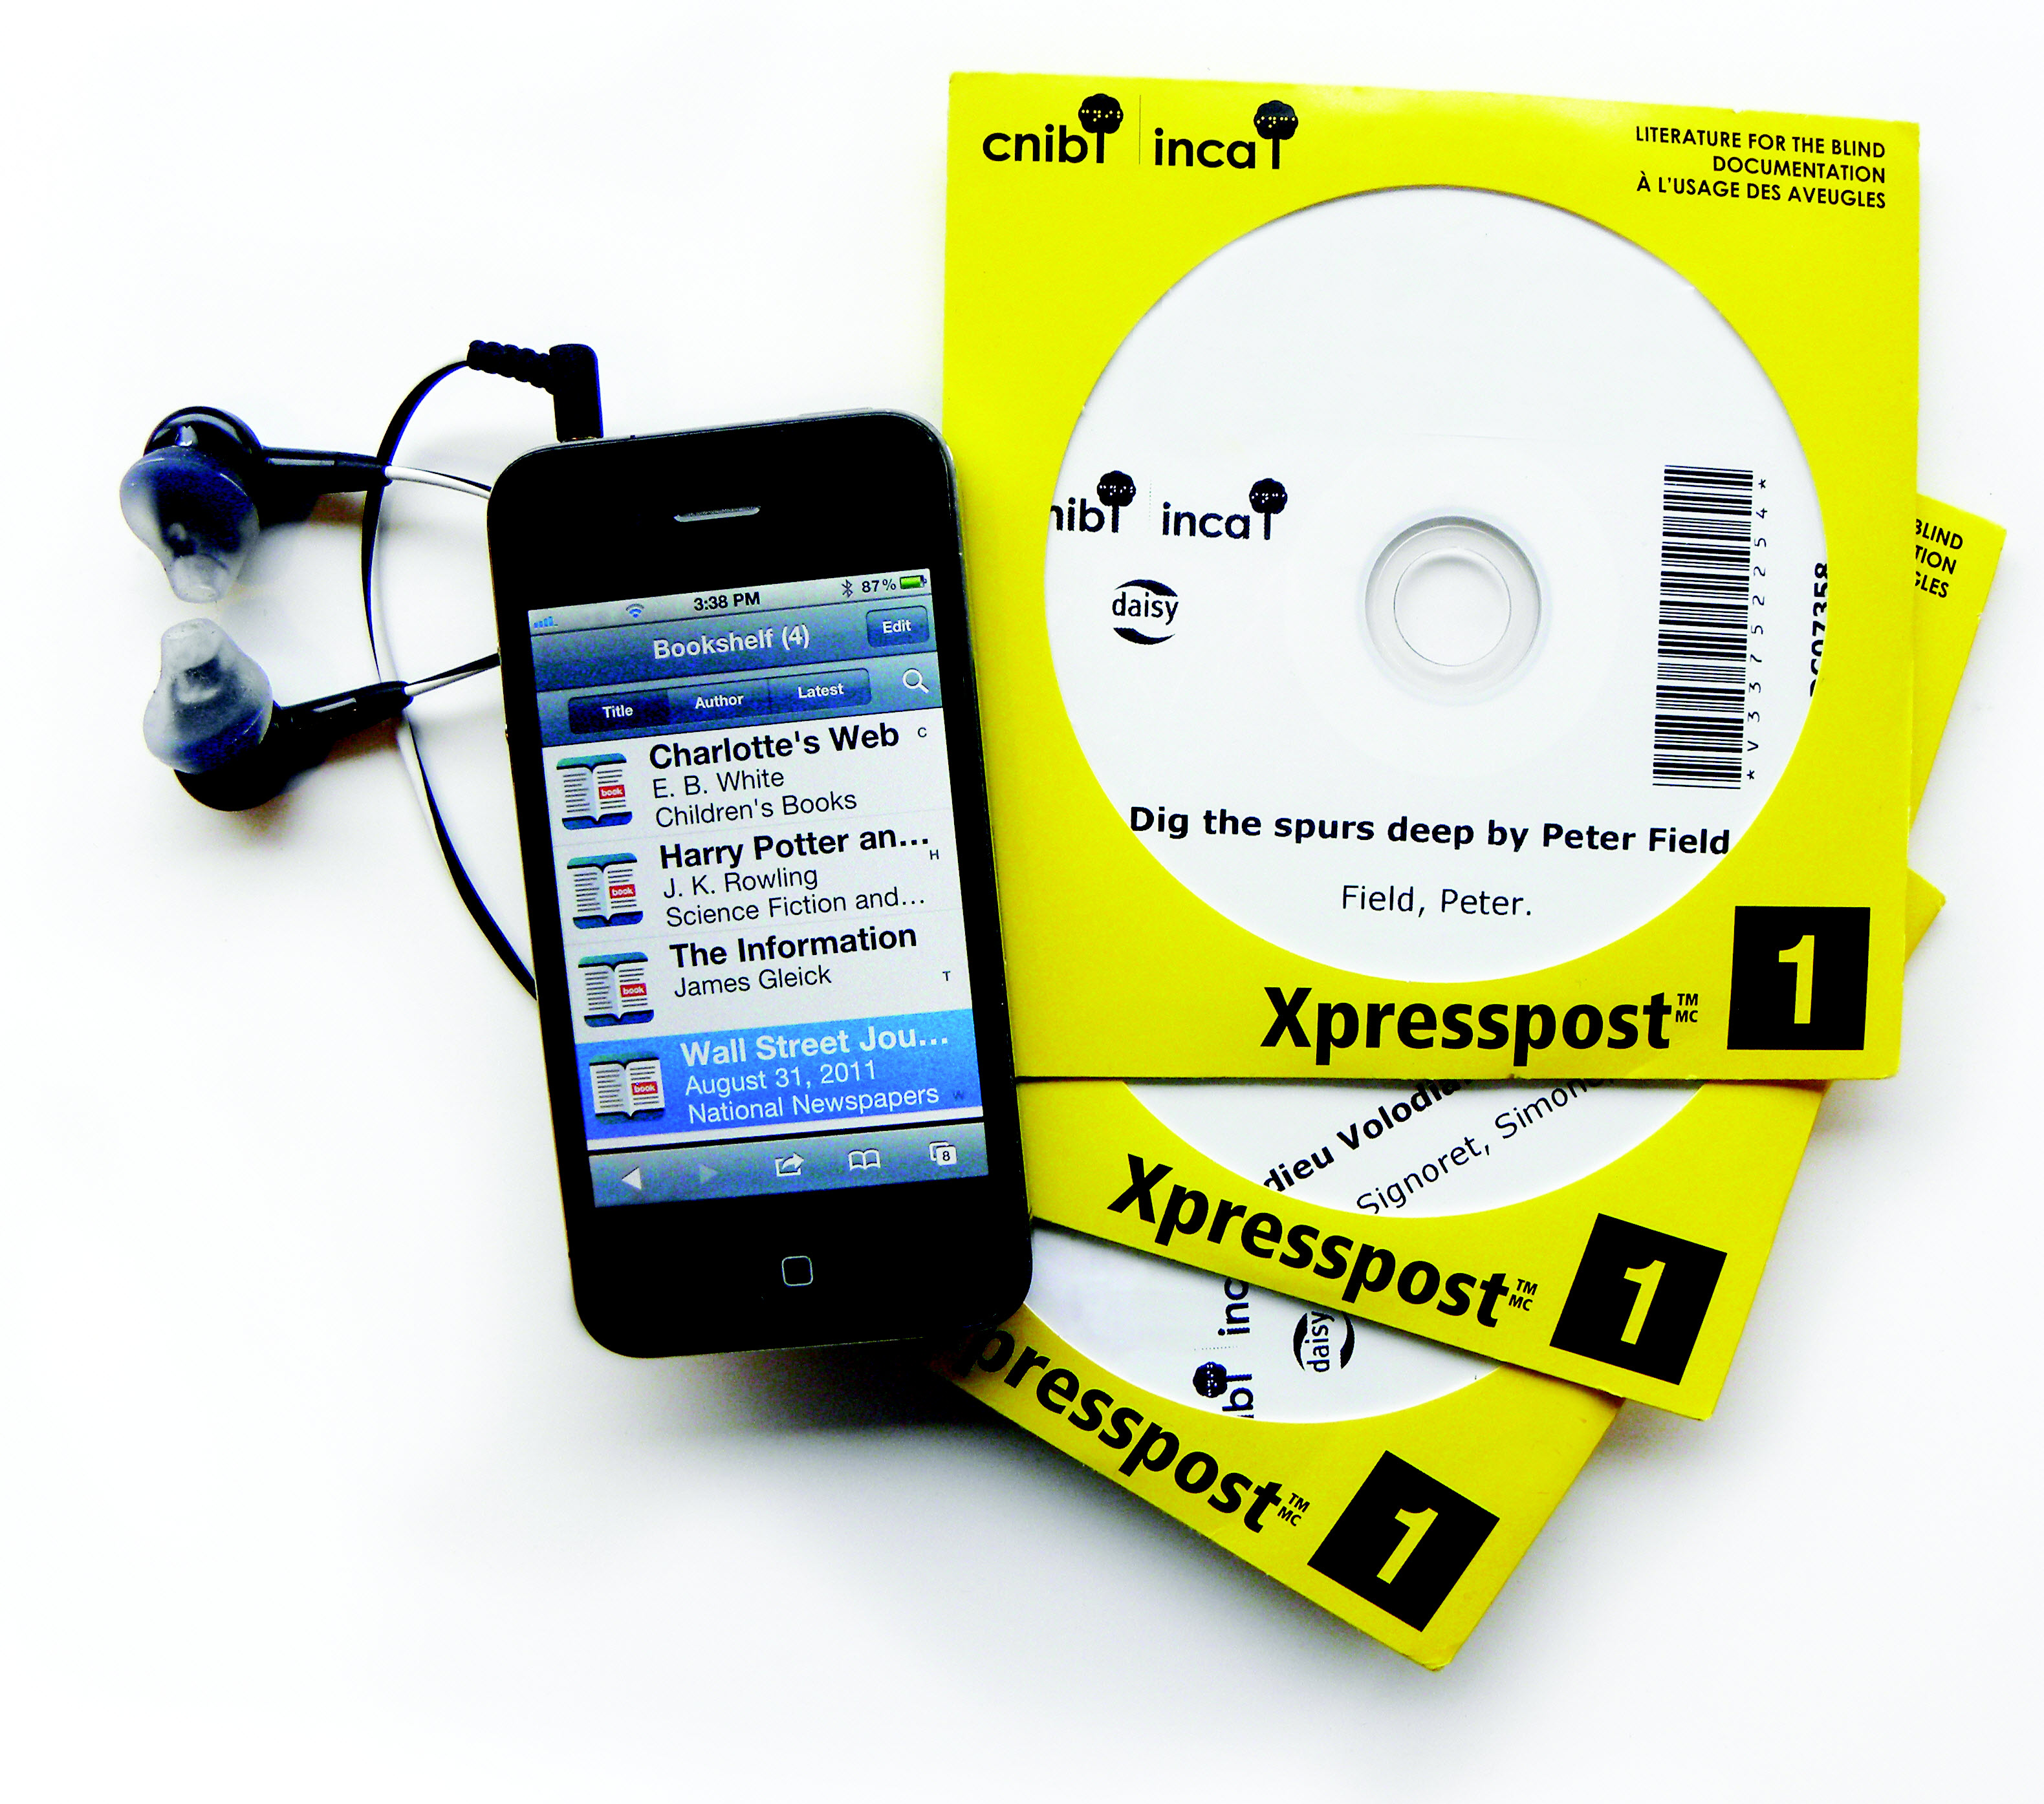

DAISY Compatible Devices

There are many ways to read a DAISY audio book. Here are some common hardware and software used to read DAISY books. For a full list of DAISY software, see: [daisy.org/info-help/guidance-training/reading-systems](https://daisy.org/info-help/guidance-training/reading-systems).

[Direct to Player](https://celalibrary.ca/services/delivery-options/direct-to-player) download books to your player.

DAISY player

DAISY players are easy to use and play DAISY, as well as MP3 and commercial audio CDs. Users can benefit from the full navigation and features of DAISY audio books. They cost between $200 and $655.

Apps for mobile devices

These apps offer all the features of DAISY audio books including full navigation controls and adjustable reading speed. [daisy.org/info-help/guidance-training/reading-systems](https://daisy.org/info-help/guidance-training/reading-systems)

Home computer

There is a variety of free and licensed programs that can help you read DAISY files on your computer. For a list of programs for various operating systems, see [nnels.ca/help/daisy-software-your-computer-or-laptop](https://nnels.ca/help/daisy-software-your-computer-or-laptop).

CD or DVD player

Most CD and DVD players read the MP3 files on DAISY audio books. However, these provide limited navigation and functions compared to the DAISY player. **Note:** CELA books recorded before 2005 will not play correctly.

Features of the DAISY player - 1

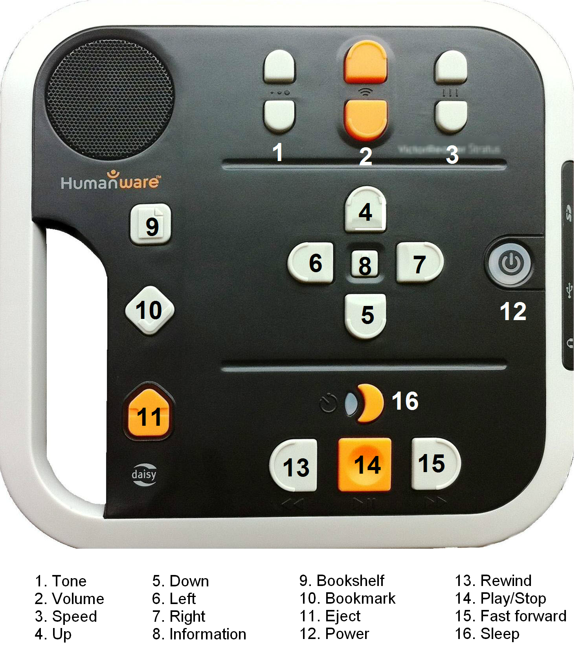

Features of the DAISY player - 2

These instructions are for the Humanware Stratus 4M player but may apply to other models and brands. This model may be used for [Direct to Player](https://celalibrary.ca/services/delivery-options/direct-to-player), audiobook download service as it connects to wireless internet. For complete instructions for your player, consult the manufacturer’s website.

[humanware.com](http://www.humanware.com/en-canada/home)

Key describer

When there is no CD in the DAISY player, the player is in key describer mode. Pressing a key will tell you its function. The info key will give you information on the player including power source, battery charge level, player version, model and serial number.

Power

Press the power key to turn the player on or off. A flashing light means the player is charging. You can use the adapter or operate on battery power. Contact the manufacturer to obtain replacement batteries.

**Inserting and Ejecting CDs**

To insert a CD, gently slide it into the slot at the bottom of the player until it is pulled into the player. The book may take a few moments to load. Once it loads, the player will announce the book title, then it will resume playback. If you are playing the book for the first time, it will start with the book info. To eject a CD, press the eject key.

**Play/Stop**

Press the play/stop key to pause and resume playback.

**Rewind, Fast Forward**

Located on either side of the play/stop key, these keys allow you to move through the book quickly. Press and hold the key; release to resume normal playback.

**Info**

Press the info key at any time to hear information about the CD in the player and your reading progress. This information includes: title, current position (page), time elapsed, time remaining, total number of pages (or number of books on the CD) and total time.

**Tone, Volume, Speed**

There are two keys each for the tone, volume and speed levels. Use these to adjust levels up and down. Those with comprehension disabilities or those new to audio books may prefer a slower speed. Others may find a different tone of voice easier to hear. Adjusting the speed will not affect the tone of the voice, unlike a conventional stereo.

Resetting the original tone and speed

Press the tone (or speed) up or down keys.

When you hear the beep you are at the standard setting.

Navigation

The structure of a DAISY book reflects the layout of the original print book. A book may be divided into parts, chapters, sections and sub-sections. In a DAISY book this structure is represented by levels which allow users to ‘flip through the pages’ and find the content they are looking for. Use the up and down keys to move from one level to the next. Use the left and right keys to move through the content at that level.

Bookshelf

On the Humanware Stratus 4M model, there is a bookshelf key. On other models, press the up key until you hear “Bookshelf”. Press the right or left keys to move through the bookshelf content. If it is a magazine CD, the Bookshelf (Level 1) will have the magazine titles.

**Bookmarks**

The bookmark key marks positions in the book so you can return to them later.

To place a bookmark, press and hold the bookmark key. Each bookmark you place is given a number. To access your bookmark list, press the bookmark key. Use the left and right keys to search through your bookmarks. To delete all bookmarks, go to the bookmark list, then press the bookmark key twice. Press play/stop to exit the bookmark list and resume playback.

**Sleep**

You can set a timer for the player to turn off. This key will voice the setting of OFF, 15, 30, 45, or 60 minutes. When the sleep function is on a light will turn on above the key.

Demonstrating a DAISY Player

Here are some tips on explaining how to use a DAISY player to a patron.

* The player is shipped with a mask that covers some of the keys. You may wish to demonstrate the DAISY player with the mask on to simplify the player for your patron. Please note however, that CELA magazine CDs require access to the arrow and bookshelf keys, so you must remove the mask to play them.
* Mention the position of the keys on the player as you talk about the function. Let the patron operate the player as you go through the explanation.
* There are 3 keys they need to know to use the machine:
  + Power
  + Eject
  + Play/pause
* Additionally, you can explain these keys:
  + Volume
  + Rewind
  + Fast forward
* Gauge a patron’s comfort level with the technology before explaining any additional keys.
* One way to explain the levels in DAISY books, is to tell the patron that the down arrow key announces the ways you can move through the book, such as by page or phrase. Then explain that they can use the left and right arrow keys to move through the book.
* Rewind and fast forward move through the book a few words at a time.
* When explaining the sleep key, recommend patrons place a bookmark before setting the sleep timer, so it is easier to find their exact position later.

About This DAISY Talking Book

Most DAISY books produced at the CNIB Library contain “About This DAISY Talking Book” in Level 1. It is always a good idea to listen to this section first to find out how the rest of the book is structured.

Navigating a DAISY magazine

Magazine CDs from CELA contain several magazines on one disc. To get to a specific magazine using a DAISY player, you need to use the navigation keys.

These are step-by-step instructions on how to navigate a magazine on the Humanware Victor Reader Stratus 4M, Classic X+ or X model players. When you play a DAISY magazine CD, the first item you hear is updates and new books from the library. Then the magazines follow.

1. Go to the bookshelf. Press the up key (“1” on X+ model) to activate the bookshelf. The player will say “bookshelf”.
2. At the bookshelf, you can browse through the list of magazines. Use the left key (“4” on X+ model) or the right key (“6” on X+ model) to move through the list of magazines.
3. When you hear the title of the magazine you want to read, press the “play” key.  When you hear “end of book,” you will know you have reached the end of the magazine.
4. To select another magazine at any time, press the “stop” key. Return to Step 1.

DAISY Magazine Structure

CELA magazine Service DAISY CDs contain several magazines. Each magazine includes “About this DAISY talking magazine” explaining the magazine’s layout. It is helpful to listen to this first. In this example, we are looking for the article “Media: All the News That's Free to Print” in MacLean’s Magazine (Feb. 6, 2012) on the “CELA Magazine Service 2012-2” DAISY CD.

Activity: Have your patron navigate to the issue of Reader’s Digest on a magazine CD and find an article of interest.

Navigating DAISY: Example

Most DAISY books produced at CELA contain “About this DAISY talking book” which explains the layout of the book. It is helpful to listen to this first. In this example, we are looking for a recipe for lobster bisque in “In the Heat of the Kitchen” by Gordon Ramsay.

Navigate by Headings

1. Press the **up** key to reach Level 1.
2. Use the **right** key to move through the headings until you reach Shellfish. The chapter on Shellfish will begin to play automatically starting with an introduction.
3. Press the **down** key to reach Level 2.
4. Use the **right** key to move through the recipes until you reach Lobster Bisque. The recipe will automatically begin to play.

 

Web: celalibrary.ca

Email: [members@celalibrary.ca](mailto:Members@celalibrary.ca)

Phone: 1-855-655-2273, extension 2