Guide to registering your patrons with print disabilities for CELA

This guide is intended to help you register your patrons for CELA. Whether it’s your first time, or you just need a refresher, you’ll find tips to help you understand CELA’s service to support your patrons.
CELA is a not-for-profit organization that provides thousands of book titles in audio, e-text and braille formats for your patrons with print disabilities through public libraries.
Your patrons who cannot read print due to a learning, visual or physical disability may sign up for CELA for free to enjoy a wealth of fiction, non-fiction, magazine and newspaper titles in alternate formats.
Contents
Guide to registering your patrons with print disabilities for CELA 1
Before you begin 2
CELA account information 2
View in-progress registration forms 2
Registering patrons 2
Patron details 2
Designate information 3
Contact Details 3
Eligibility 4
Bookshare and Proof of Print Disability (optional) 5
Delivery options 6
Formats 7
Privacy and Terms of Use 7
Submitting the form and next steps 8

Before you begin

CELA account information
You’ll need to log into https://celalibrary.ca using your CELA 6-digit account number. You may log in to register a patron from any of your CELA accounts.

View in-progress registration forms
You may complete a registration for someone all at once or enter partial information and save it before leaving the form. Go back to the form later by selecting the “Library patron registration” link, then select “View in-progress registration forms”.

Registering patrons

- Log in to celalibrary.ca and find the link to the form under the “Library Services” heading.
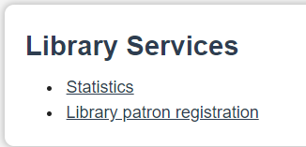
Select “Register a patron for CELA service” and begin filling out the form.

Patron details

The form begins by asking for the patron’s full library card number and contact information.
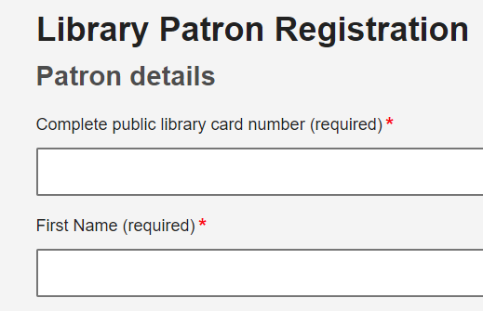

Designate information

Some patrons may wish to add a person to their account who can order books or make changes on their behalf. It’s fairly common for older members to add an adult child or caregiver. It’s highly recommend for patrons under the age of 18 have a parent or guardian as a designate. As library staff, if you order all the books for some of your patrons, the patron may ask to add yourself as their designate.
It’s important that patrons understand that a designate will have access to all their CELA information and reading history and can make changes to their account, including updating personal information such as their address.
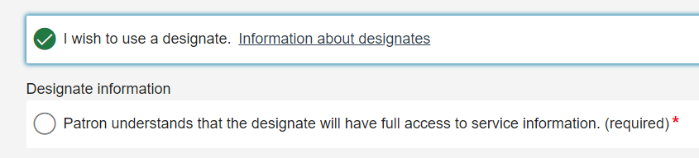
We provide information about the role of designates on our Designates page.

Contact Details

We ask for the person’s mailing address, phone number and email address.
Please note that if the person wishes to download materials from our site, they must provide an email address.
CELA also sends patrons a monthly newsletter called Open Book, which is the main way we let our patrons know about newly-added books as well as about any service updates and changes. Patrons may unsubscribe from Open Book at any time.

Eligibility

CELA’s collection is available to your patrons who cannot read print due to a learning, visual or physical disability where they cannot hold a book or turn its pages. Collectively these are called “print disabilities”. The patron will self-declare that they have a print disability and you must answer “Yes” to this question to be able to move on in the form.
We also ask if you could let us know what type(s) of print disability(ies) someone has. However, this question is optional.
The definition of print disability is taken from the Canadian Copyright Act because it is this Act that gives CELA permission to reproduce published materials in alternative formats for its collection. The term used in the Act is “perceptual disability”.
Still not sure if your patron is eligible? This table defines each type of print disability and lists some common conditions:
Learning: An impairment relating to comprehension
- dyslexia
- some forms of autism where changing the format of the text assists the reader
- brain injury
Visual: Severe or total impairment of sight or the inability to focus or move one’s eyes.
- numerous serious eye conditions such as macular degeneration
- total blindness
Physical: The inability to hold or manipulate a book.
- Parkinson’s disease
- Muscular dystrophy affecting the upper body
- Cerebral palsy
- Stroke affecting hand and arm movements
- Multiple sclerosis
- Severe arthritis
When is it not a print disability?
There are times when you may not be sure if the person has a print disability. If you or your patron are not sure, feel free to contact Member Services. Here are some tips that can help:
- If the person has one of the three categories of print disability and needs the format changed from text to audio, e-text or braille to be able to read - they qualify for CELA.
Examples of patrons not qualifying for CELA
- Those who use English as a Second Language (ESL) materials, without having one of the three types of print disabilities
- Intellectual disabilities
- Eye conditions related to normal aging that are not severe
- Wearing prescription glasses for common eye conditions that are not severe

Bookshare and Proof of Print Disability (optional)
CELA does not require proof of disability. However, if your patron wants access to Bookshare titles in our catalogue, they must provide a signed Proof of Disability form. Bookshare is a US alternate format online library and requires a signed proof of disability form as per Bookshare’s agreement with publishers.
Tips to consider if your patron would like Bookshare titles:
- All Bookshare audiobooks are read using synthetic voice and braille is generated automatically. Some patrons don’t mind a slightly robotic voice, but others prefer only human-narrated books.
- Access to Bookshare titles may be added at any time after the patron registers.
- Bookshare offers a wide selection of popular and newly published titles and has many more titles in Epub, Word and DAISY text formats than CELA. These formats are helpful for those who need or prefer to see the text either through enlarging it on their screen or seeing the words and listening to the text at the same time.
- Bookshare has some titles available in languages other than English and French, for your patrons who read other languages.

Delivery options
CELA members may receive books in three ways:
- Audio books or e-text straight onto a tablet, cell phone or DAISY player. This service is called Direct to player and requires the person to download the EasyReader app or have their DAISY player configured by one of CELA’s technicians. The person must have an internet connection. We highly recommend this as the best option for a few reasons:
  - No trips to the mailbox or post office (especially in winter!)
  - Keep receiving books even if there is a slow down with the mail service
  - No worries about losing CDs and not sending them back which could eventually stop someone’s service
- Physical CDs, braille and printbraille in the mail
- Online access where the person can download the Zip file for any book or magazine title and read it as an audiobook, an e-book or a braille book which is read on a device called a braille display.
Choosing a delivery option
Does your patron not know which option to choose? You can start by asking what devices your patron has and how comfortable they are with technology.
Do you have a DAISY player or cell phone or tablet and an internet connection?
If yes, choose “DAISY audio or accessible text delivered to Direct to Player or mobile devices”. On a cell phone or tablet, they will need to download the EasyReader app (free) or VoiceDream app (fee applies).
Do you have a computer and an internet connection?
If yes, choose “No delivery, download from website (all formats)”. When the patron selects books on CELA’s site, they’ll choose the Zip audio or Zip text to download the book or magazine file. They may also transfer the file using an SD card or USB stick to a DAISY player. Patrons with a cell phone or tablet and an internet connection may also access books and magazines as Zip files using either the EasyReader on Android or VoiceDream app.
Do you have a DAISY player or a CD player that plays mp3 files but no internet connection?
Choose “Physical braille, printbraille or DAISY audio books and magazines on CD delivered by mail.”

Formats
After choosing how the person will receive their books, the next question will ask what format they wish to read.
If your patron wants to receive CDs in the mail, for example, you would choose “Physical braille, printbraille or DAISY audio books and magazines on CD delivered by mail” on the Delivery Options screen:
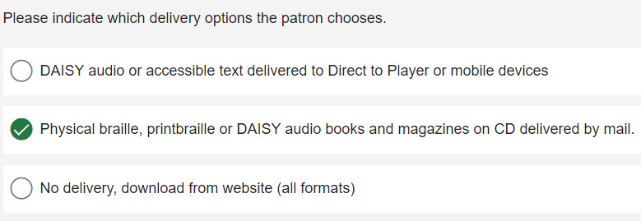

And “DAISY audio books and magazines on CD” on the Formats screen:
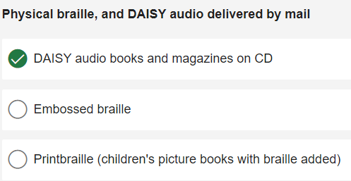

Privacy and Terms of Use
Since CELA’s collection is only for use by the person with the CELA account, we ask that they agree to our Privacy and Terms of Use policies. All you need to do is read out this sentence on the form “CELA’s cellections and services are for your use only. I agree to CELA’s terms.” Once they agree, select “Yes” to continue to the next page.

Submitting the form and next steps

You’re almost ready to submit the form. You have the opportunity to add any additional comments at this point. Please add any other important information we should know when setting up the patron’s service. For example, if you already know the patron’s reading preferences for automatic selection service, you can provide them in the comments.
What happens after you submit the form?
A message will appear on your screen thanking you for submitting the form and will explain the next steps. At the same time, the patron’s account is being created in our system and they will receive an email containing a Welcome Message and their username and password sometime that day.
At this point, you’re finished registering this patron for CELA. The patron should expect the following:
We send a welcome email to the patron and/or their designate if an email address is provided.
If no email address is provided, we send a welcome message by Direct to Player or on CD.
If CDs or Direct to Player service was selected, we send two popular books to get the patron started. New patrons should call us at 1-855-655-2273 to set up automatic selection service, or they can log in to choose their own books.
If braille or printbraille is selected, we’ll call the patron to set up service.

