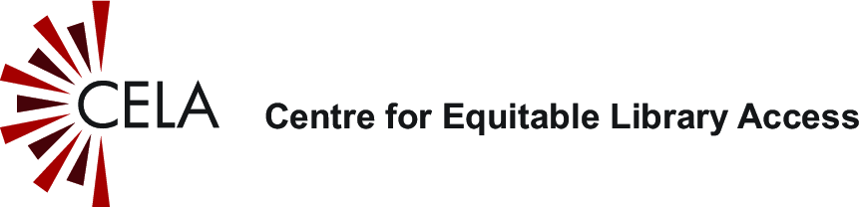
Customizable Facebook post or newsletter article on CELA Educator Access Program

Have a student with a print disability?

Connect them to accessible reading!

If you're an educator supporting a student with a print disability you can receive free access to thousands of accessible reading materials for your student through your public library's [optional: specify public library name.] CELA Educator Access Program.

What can you access though CELA?
- 800,000+ accessible books in audio, braille, or accessible e-book
- Free Bookshare organizational account for your school
- Award winners, best sellers and classroom favourites for kids & teens
- Fiction and non-fiction for adults, academic materials
- Free Dolphin EasyReader app for iOS or Android devices
- Training videos, tutorials, and webinars
Sign up today at celalibrary.ca/educators or ask at your public library. [Optional: indicate public library contact information.]

