CELA and EasyReader Cheat Sheet

Step 1 - Using your device, go to the Google Play or Apple store—search EasyReader
Step 2 - Download the Dolphin EasyReader app to your device
Step 3 - Sign up for a Dolphin account
- New user—create a Dolphin account using your email address
Now you’re ready to use EasyReader! Begin by opening the app and signing in with your Dolphin account.

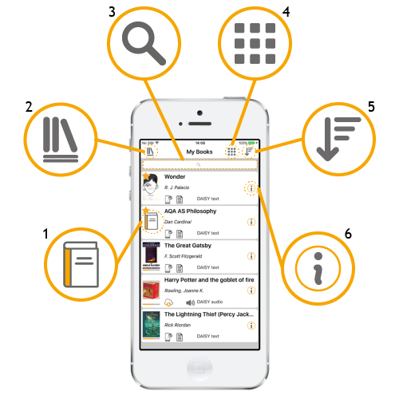
Step 4 - Familiarize yourself with EasyReader Buttons
- Book cover - tap to open the book
- Side menu - Find a new book or newspaper to read from a library or open a clipboard text to read.
- Search - Search your My Books list for a title you have already downloaded.
- List/Tile view (iOS only)- Choose to display your My Books list as either a list or as tiles.
- Sort - Sort your My Books list by title, author or most recently read.
- Book information - Find information about the book, such as the title, author, format, size, a synopsis where available and the option to delete borrowed items from your device.

Step 5 - Sign in to CELA Library—select the side menu button (#2 above), choose CELA Library from the list, and enter your CELA six-digit account number.
Step 6 – Choose books! – if you have automated selection set up, you will find titles in the CELA Library section on the app. If you wish to choose your own titles, go to celalibrary.ca, login to your CELA account, find a book and choose the Direct to Player audio or text format.
Step 7 – Borrow a Book from CELA—select the side menu button (#2 above), select CELA Library. Select a book. View the book information, touch the Borrow icon and then select Download. After borrowing and downloading the book, you can now find that book in My Books as well as in the listings of books in your CELA Library.
Step 8 – Open a Book—select the side menu button (#2 from above) and then select My Books from menu. View the books you’ve downloaded and select the Book Cover (#1 above) to open that book. *Note-once you’ve downloaded a book you DO NOT need to be connected to Wi-Fi to read it. They are stored to your device.
Step 9 – Set Text Preferences—Select the A Icon in the upper right corner of the book to adjust: Text Size, Font, Margins, Line Spacing and Colors.
Step 10 – Set Audio Preferences—Select the Speaker Icon in the upper right corner of the book to adjust: Rate, Pitch, Volume and Pause.
Step 11 – Explore Navigation Buttons—at the bottom of the book there are buttons that enable you to: Go Back, Go to the Index, Rewind 15 second, Play, Fast Forward 15 seconds and Set the Timer.
Step 12- Set a Bookmark—While reading a book, you can set a bookmark by selecting the text or chapter heading you want to return to, once it’s highlighted, select the Bookmark Icon at the upper right corner of the book. You can have as many Bookmarks as you like and can make text and voice notes for yourself referencing the Bookmark.
Step 13 – Read Tons of Books!

Need help? Call or email the CELA Contact Centre at 1-855-655-2273 or help@celalibrary.ca

